Mount Lawley Senior High School 2013
2XHIM Modern History, Year 11. Semester 1
Document Study: Intolerance in 1920’s American Society.
Source Selection
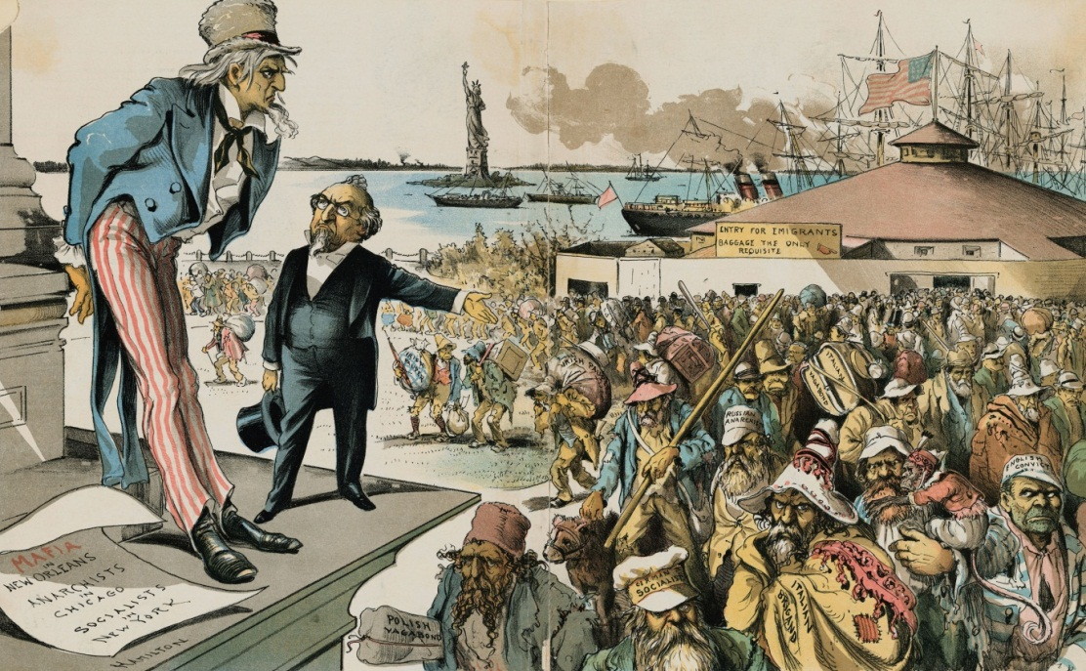
Source 1
Immigrants are labelled:
- German socialist.
- Russian anarchist
- Italian brigand (outlaw)
- English convict
Newspaper reads:
“Mafia in New Orleans.
Anarchists in Chicago.
Socialists in New York
Where the blame lies.
Judge to Uncle Sam: “If immigration was properly restricted you would no longer be troubled with Anarchy, Socialism, the Mafia and such kindred evils!”
Anti-Immigration or Nativist cartoon published in New York, 1891.
Source 2
“I am suffering because I am a radical and indeed I am a radical; I have suffered because I was an Italian, and indeed I am an Italian; I have suffered more for my family and for my beloved than for myself; but I am convinced to be right that if you could execute me two times, and if I could be reborn two other times, I would live again to do what I have done already”
Bartolemeo Vanzetti’s last statement to the court on 9th of April 1927 as his final appeal is turned down. Sacco and Vanzetti were executed on 23rd of August.
Source 3
A Ku Klux Klan Imperial Wizard explains the origin and purpose of his organisation:
“The Klan, therefore, has now come to speak for the great mass of Americans of the old pioneer stock….These are, in the first place, a blend of various peoples of the so-called Nordic (hint: Norway, Sweden, Finland, Denmark) race, the race which, with all its faults, has given the world almost the whole of modern civilisation. The Klan does not try to represent any people but these.
…From the first only, hardy, adventurous and strong men and women dared the pioneer dangers; from among these all but the best died swiftly, so that the new Nordic blend which became the American race was bred up to a point probably the highest in history…
Quoted from Evans, H.W (March-May, 1925) The Klan’s Fight for Americanism. Printed in North American Review, pp 38-51.
Source 4
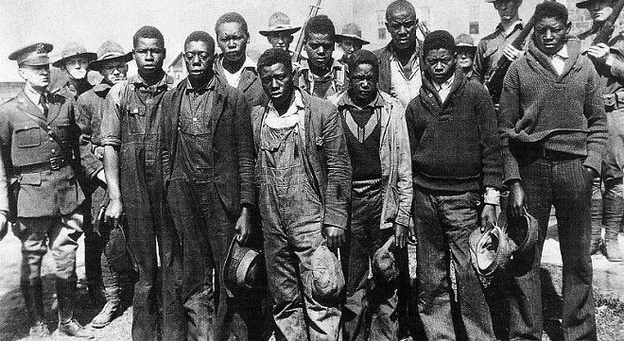
The 9 young African-American men who would later become known as the “Scottsboro Boys” shortly after their arrest on allegations of rape and assault, March 25th 1931.
Source 5
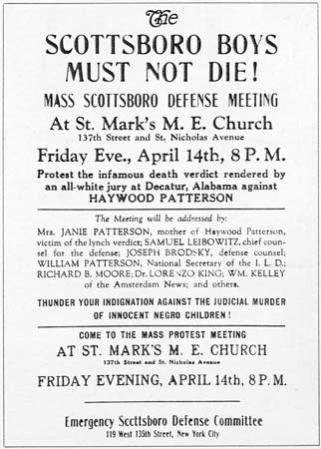
A poster designed to raise support for the Defence Committee for the Scottsboro Boys during their 1932 trial. The legal arm of the Communist Party in America, the International Labor Defence (ILD), organised and paid for the 9 men’s legal representation.
Source 6
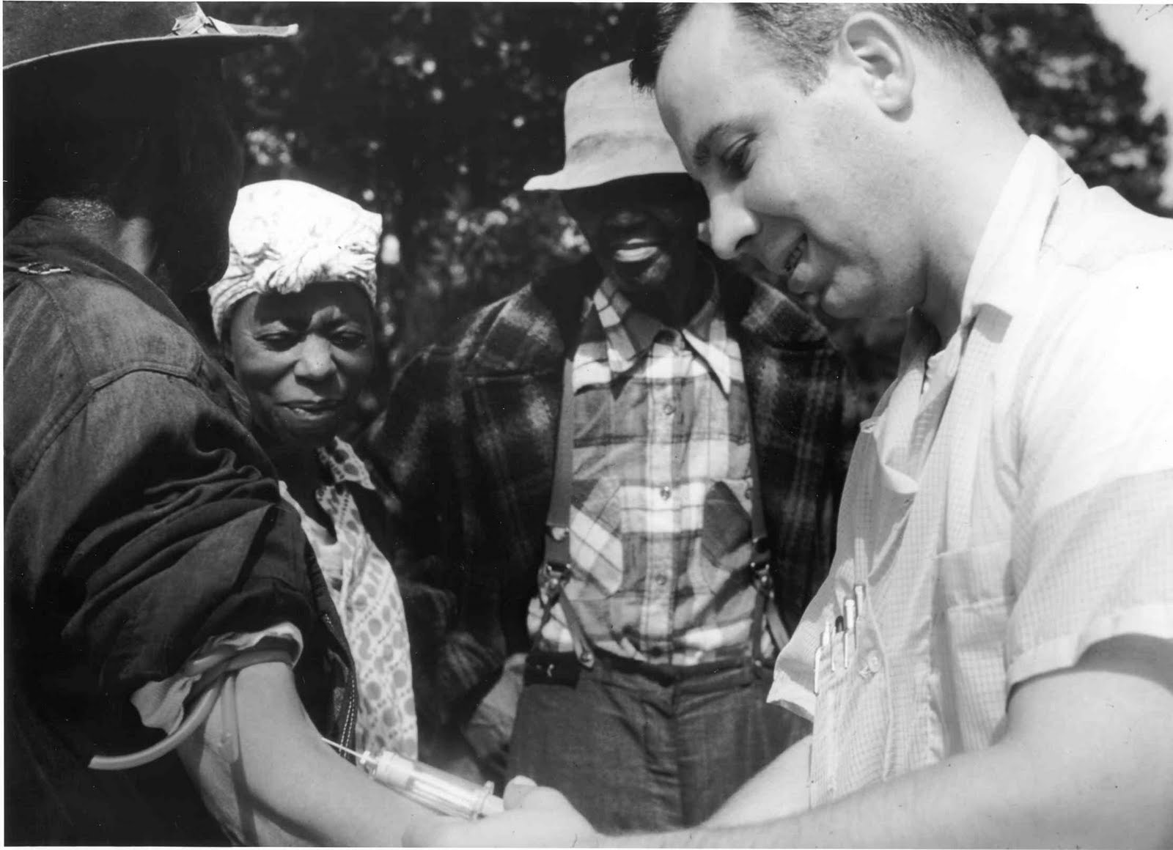
African-American “Sharecroppers” receiving injections in 1932 that they believed were a part of a free healthcare scheme run by the Government. They were actually participants in the Tuskagee Syphilis experiments.
Source 7
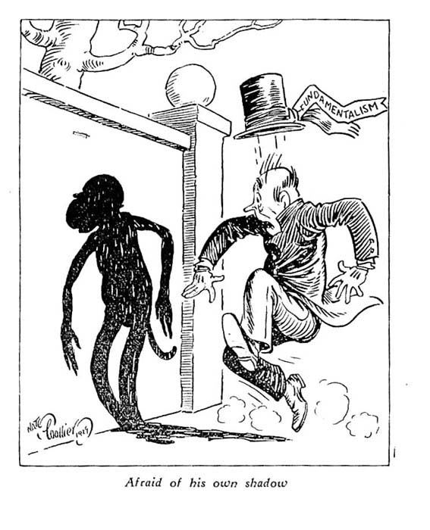
Cartoon published in Evolution: A Journal of Nature in 1927

Question Booklet
- What is Source 1 saying about the attitude of American society towards immigrants in the 1890’s? What events contributed to the growth of this belief in the 1920’s? (3 marks)
_______________________________________________________________________________________________________________________________________________________________________________________________________________________________________________________________________________________________________________________________________________________________________________________________________________________________________________________________________________________________________________________________________________________________________________________________________________________________________________________________________________________________________________________________________________________________________________________________________________

- What specific events in the early part of the 20th century would have led Sacco and Vanzetti to believe that they were being arrested for radicalism and being Italian? (2 marks)
__________________________________________________________________________________________________________________________________________________________________________________________________________________________________________________________________________________________________________________________________________________________________________________________________________________________________________________________________________________________________________________________________________

- What does Source 3 reveal about the beliefs and values of the Ku Klux Klan in the 1920’s?
(3 marks)
_______________________________________________________________________________________________________________________________________________________________________________________________________________________________________________________________________________________________________________________________________________________________________________________________________________________________________________________________________________________________________________________________________________________________________________________________________________________________________________________________________________________________________________________________________________________________________________________________________________
- How does this image of the Scottsboro Boys convey the unequal position of African Americans in the 1920’s? (2 marks)
______________________________________________________________________________________________________________________________________________________________________________________________________________________________________________________________________________________________________________________________________________________________________________________________________________________________________________________________________________________________________________________________

- Why did the ILD choose to represent the Scottsboro Boys in their defence? What other interest groups may have acted to counter the intolerance shown in the 1920’s? (4 marks)
____________________________________________________________________________________________________________________________________________________________________________________________________________________________________________________________________________________________________________________________________________________________________________________________________________________________________________________________________________________________________________________________________________________________________________________________________________________________________________________________________________________________________________________________________________________________________________________________________________________________________________________________________________________________________________________________________________________________________________________________________________________________________________________________

- Source 6 shows African Americans willingly participating in the Tuskagee medical trials. What methods did the Public Health Authority use to coerce the participants and what does this say about the states attitude towards African Americans at the time? (3 marks)
_____________________________________________________________________________________________________________________________________________________________________________________________________________________________________________________________________________________________________________________________________________________________________________________________________________________________________________________________________________________________________________________________________________________________________________________________________________________________________________________________________________________________________________________________________________________________________________________________
- Explain the context (who, what, why, when, where) that lead to the publication of Source 7. (3 marks)
_______________________________________________________________________________________________________________________________________________________________________________________________________________________________________________________________________________________________________________________________________________________________________________________________________________________________________________________________________________________________________________________________________________________________________________________________________________________________________________________________________________________________________________________________________________________________________________________________________________
8. To what extent do these sources reflect your understanding of the period? Hint: How prevalent was the intolerance? How many people were actively involved and victimised? (5 marks)
_________________________________________________________________________________________________________________________________________________________________________________________________________________________________________________________________________________________________________________________________________________________________________________________________________________________________________________________________________________________________________________________________________________________________________________________________________________________________________________________________________________________________________________________________________________________________________________________________________________________________________________________________________________________________________________________________________________________________________________________________________________________________________________________________________________________________________________________________________________________________________________________________________________________________________________________________________________________________________________________________________________________

